PHY2010S Lab 2

CAPACITORS & UNCERTAINTY DEVIN STICKELLS / STCDEV001

# Aim

The aim of this experiment is to produce a rudimentary capacitor and measure its capacitance by different methods.

# Introduction

One can measure a capacitor’s capacitance in several ways. Each method of measurement has varying degrees of accuracy and differs in its associated uncertainty. In this laboratory write-up, the properties of a simple capacitor will be measure and the uncertainty analyses of these measurements will be presented.

# Method

A capacitor was constructed by taking 2 sets of wax paper and tin foil and rolling them tightly around a pen in such a way that the tin foil sheets did not touch. The capacitance was then measured as follows:

1. By calculation from the formula: where is the permittivity of free space, is the relative permittivity, A is the area of the plate and d is the plate separation.
2. By direct measurement from an Atlas Model LCR40 Passive Component Analyser
3. By indirect measurement from a Tektronix TBS1052B Oscilloscope connected to an RC circuit, and using the formula

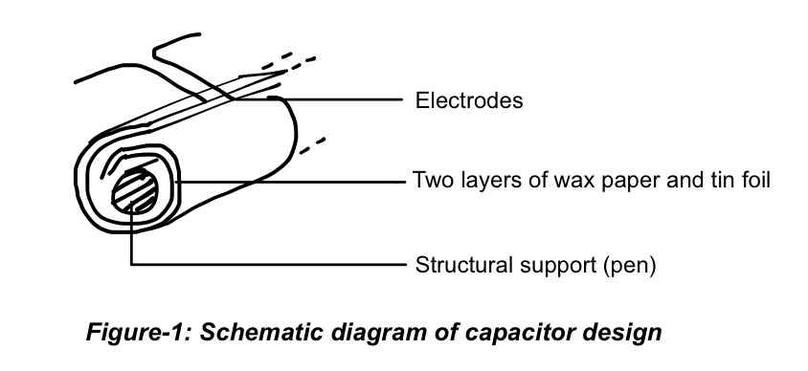

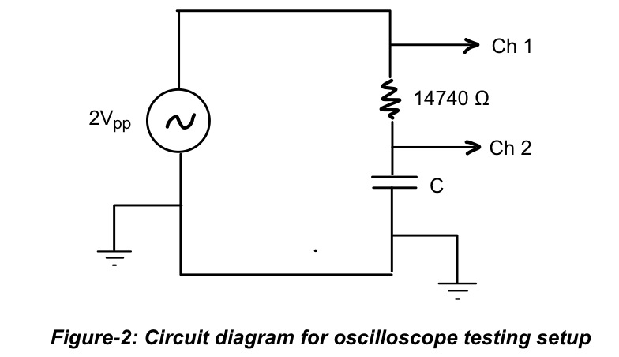

# Results

### Method 1: Calculation

This method of involves using the parallel plate capacitor formula to calculate the capacitance of the device based on its approximate physical attributes. The formula is derived from Gauss’s Law applied to charged parallel plates.

where

### Method 2: Direct Measurement

This method involves the use of the Atlas LCR40 Passive Component Analyser to measure the constructed capacitor’s capacitance. The device simply needs to be attached to the capacitor electrodes and will produce a readout of the capacitance of the component.

### Method 3: Indirect Measurement through an RC Circuit

This method involves attaching the capacitor in an RC circuit configuration to a signal generator producing a square wave. An oscilloscope can then be used to obtain the charge and discharge curves for the capacitor. When the signal generator is set to oscillate slowly enough that the capacitor is able to charge almost to saturation voltage every cycle, we can use this charging curve to calculate the capacitance by recording the time it takes for the capacitor to charge to 63,2% of its maximum voltage - ie, to complete 1 RC time constant.

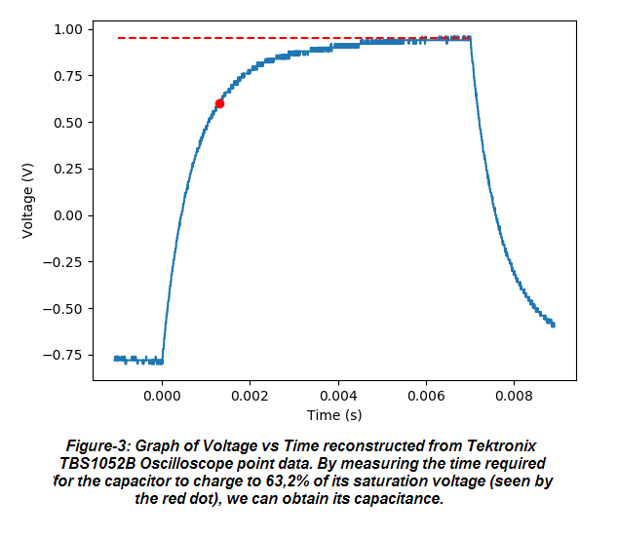

where

# Discussion

|  |  |  |
| --- | --- | --- |
| **Source of Uncertainty** | **Type** | **Associated Uncertainty** |
| Digital Atlas LCR40 Passive Component Analyser | Type B |  |
| Digital Tektronix TBS1052B Oscilloscope | Type B |  |
| Ruler for analogue plate are measurement | Type B |  |
| Digital Calliper for plate thickness | Type B |  |
|  |  |  |

***Table-1: Uncertainty Budget***

Beyond the uncertainties accounted for and quantified in Table-1 which are propagated through the calculations used to compute the overall uncertainties presented in this write-up, the following are also to be taken note of: uncertainty in the relative permittivity of the wax paper used; the resistance of the capacitor electrode leads; the effects of temperature in the relative permittivity of wax paper - and hence the capacitance.

# Conclusion

The first method - calculation - yielded a capacitance, . The second method - direct measurement - yielded , and the third method - indirect measurement - gave us . Of these three methods of testing, my inclination is that the second one, direct measurement is the best. Though the direct measurement instrumentation is less precise than the indirect measurement instruments, direct measurement - as a method of testing - is less prone to influence by external factors, and so would be more accurate, in my opinion. The instrument can be factory tested for a very specific job, and the majority of possible problems are implicitly mitigated - since the device attaches directly, and only, to the capacitor. It is also highly convenient to measure capacitance directly and this tool could save one vast amounts of time.

This experiment could have benefitted, or been improved, by being performed in a static-free, temperature-controlled environment, where multiple readings were taken and averaged, using more precise instrumentation. The capacitor itself could have been wound tighter and in better alignment with itself.

